**How to Start with JDBC**

1. **Pre-requisite**
   * 1. **An IDE (Eclipse IDE, NetBeans etc)**
     2. **MySQL or Oracle DB**
     3. **A driver (MYSQL Driver or Oracle Driver based on Database Used)**
2. **Objective**

* **We are going to connect our Java program to My SQL Database in order to perform Database related operations (CRUD operation).**

1. **Steps**
2. **Creating Project and Setup**

* **Go to file menu, click on new, and search or select for Java Project.**

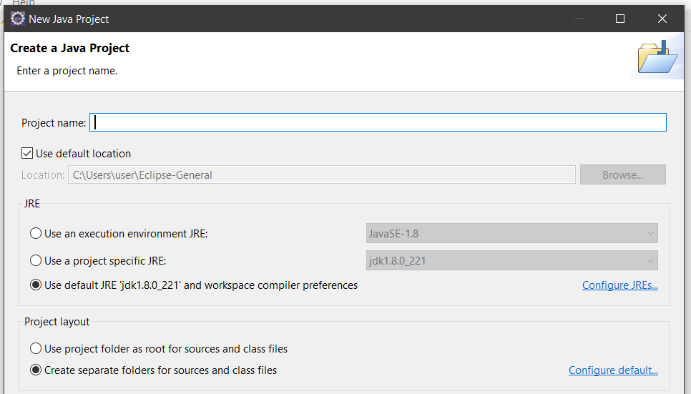

* **Give the name, and click on finish.**
* **Folder Structure**



1. **Adding driver to the project**

* **Create a folder (Eg library or driver etc name)**

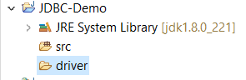

* **Copy paste the downloaded driver in the folder.**

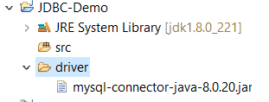

1. **Linking driver to the project**

* **Go to Properties and search for Java Build Path.**
* **Go to Libraries Tab**

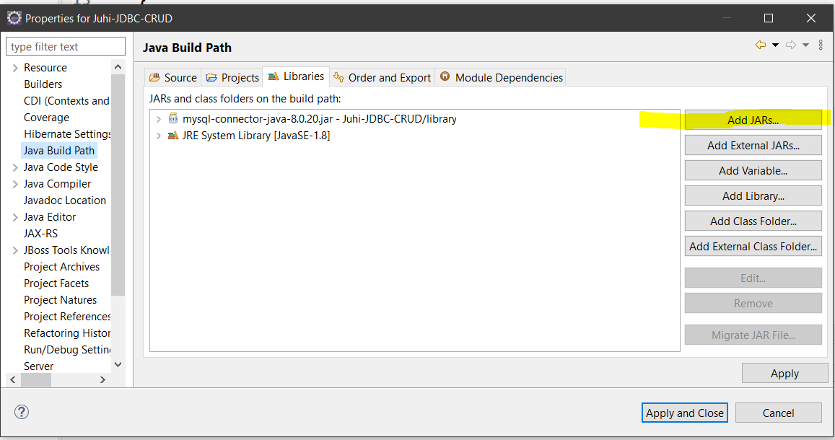

* **Click on Add JARs and select the driver from that folder (library or driver).**
* **Click on Apply.**

**----------------------------- Project Setup is Complete------------------------------**